Wind (Spacecraft)

On November 1st, 1994, at 09:31 UTC, Delta II 7925-10 carried the Wind Satellite off the Space Launch Complex -17 in Cape Canaveral, Florida. (Wind (Spacecraft),1). The Global Geospace Science Wind satellite was a NASA science spacecraft manufactured by Martin Marietta. “For the past 25 years, Wind has been studying the heated gas of charged particles — known as plasma — that fills the space between planets.” (Tran, Lina, 2). It studies this space by being placed in a halo orbit around L1 Lagrange Point and through an array of six instruments. Wind has contributed to over 5,000 publication, 100 graduate degrees, and now one more Satellite’s Mini-Project.

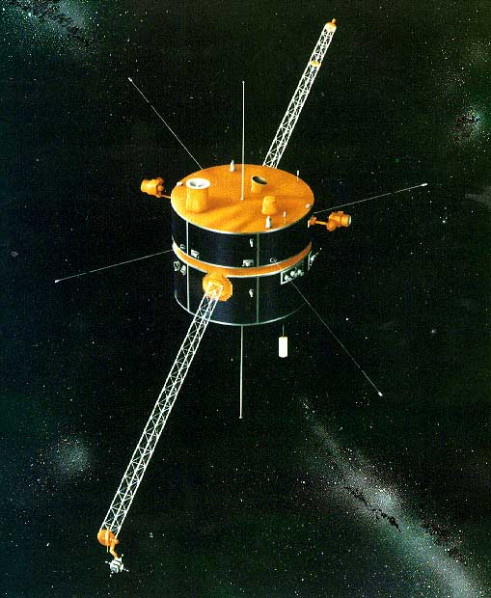

Figure 1 Wind is the first of NASA's Global Geospace Science program

The Delta II rocket was divided into three classes, Delta 6000, Delta 7000, and Delta 7000H. The Delta II 7925-10 used to carry Wind was of the Delta 7000 class. Of 132 Delta 7000 launches, 130 were successful. The Delta 7000 class began on November 26th, 1990 and ended on September 15th, 2018, averaging one launch every 77 days. “The Delta II 7925 employs nine GEM's (Solid Rocket Motors), and with the 9-foot, 6-inch diameter payload fairing can carry a maximum 4,120-pound payload to geostationary transfer orbit or a maximum 2,900-pound payload to Earth-escape trajectory.” (Rockets and Missiles, 3). This Delta II configuration was required for the Wind spacecraft with a Launch Mass of 1,250 kg (2,760 lbs.) leaving only 140 lbs. excess.

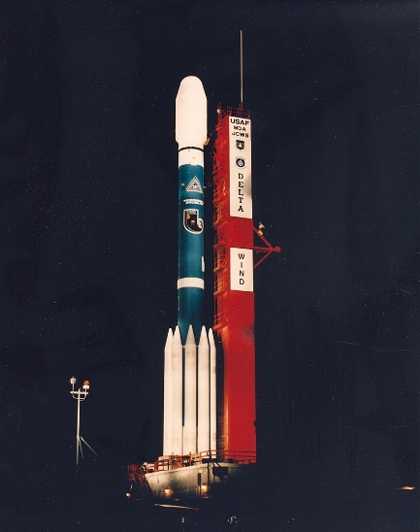

Figure 2 Wind spacecraft in fairing on Delta II rocket waiting for launch

Global Geospace Science (GGS) is a NASA space program responsible for the operation of two satellites, Wind and Polar. Polar was used to study polar magnetosphere and aurorae starting in February 1996, a 2-year mission that lasted 12 years and 2 months. (Polar (Satellite), 4). Wind was designed and manufactured by Martin Marietta Aerospace Division; Martin Marietta later merged with Lockheed Corporation in 1995 to form Lockheed Martin. The Wind satellite is spin-stabilized cylindrical satellite with a height of 1.8m and diameter of 2.4m. It has an operational power of 370 watts and currently has enough fuel to last over 55 years at L1.

The Global Geospace Science mission operations are based out of the Multi-Mission Operations Center at Goddard Space Flight Center. Wind takes part in the International Solar-Terrestrial Physics Science Initiative; this initiative hopes to understand the behavior of the solar-terrestrial plasma environment. This research will help to predict how the Earth’s atmosphere will respond to solar wind variations. Within this initiative, Wind’s objective is to measure the properties of solar wind prior to its interaction with Earth. The study of solar wind is completed by four main investigation tasks. Wind proves complete plasma, energetic particle, and magnetic field input for magnetospheric and ionospheric studies. Wind helps determine the magnetospheric output to interplanetary space in the up-stream region. Wind investigates basic plasma processes occurring int the near-Earth solar wind. Finally, Wind helped to provide baseline ecliptic plane observations to be used in heliospheric latitudes by the Ulysses mission. (Wind (Spacecraft), 1).

`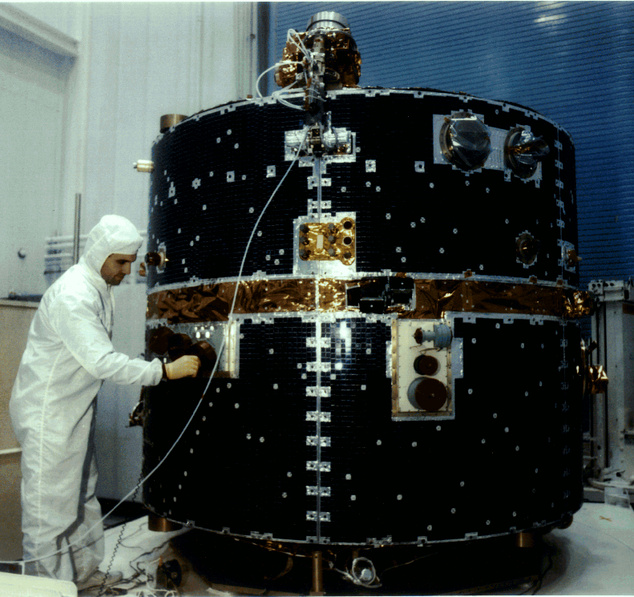

Figure 3 Image of the WIND Satellite

The study of solar wind and its properties require delicate and precision equipment. On board Wind sits KONUS and TGRS, these instruments study high energy photon and gamma ray observations of solar flares or gamma ray bursts. The Magnetic Field Investigation (MFI) and WAVES instruments measure the electric and magnetic fields observed in solar winds. The Three-Dimensional Plasma and Energetic Particle Investigation (3DP) and Solar Wind Experiment (SWE) are designed to measure and analyze the low energy (x<10MeV) solar wind protons and electrons. Lastly, The Energetic Particles: Acceleration, Composition, and Transport (EPACT) instrument is “designed to make comprehensive observations of solar, interplanetary, and galactic particles over wide ranges of charge, mass, energy, and intensity using a combination of 8 different particle telescopes.” (“The Energetic Particles: Acceleration, Composition, and Transport (EPACT) Investigation on the Wind Spacecraft”, 5).

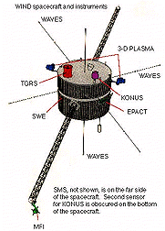

Figure 4 The Wind Spacecraft Instruments

After 25 years of service, Wind still provides us with valuable and essential data about the solar system and solar wind. These discoveries have had a huge influence in the scientific community, within UNH we study the solar wind magnetosphere interactions and the magnetic reconnection in Space Plasma Physics (PHYS 712). Other fascinating discoveries / contributions made by Wind include Solar Radio and Interstellar Dust. “Early in its mission, Wind tuned in to the radio frequencies of the Sun. By listening in, Wind was able to detect a hum coming from our star. By tracking the minute changes in this frequency, scientists can remotely observe the surface of the Sun and the space weather that comes towards Earth.” (Tran, Lina, 2). Interstellar Dust was noticed by large spikes in the electric field detectors. This was determined to be hyper-fast dust particles impacting the spacecraft and creating tiny explosions of plasma. So far, Wind has experienced well over 100,000 dust particle impacts. (Tran, Lina, 2). These are just two of Wind’s discoveries and contributions, over the next 55 years we will continue to learn more and more about our universe from this ancient spacecraft.

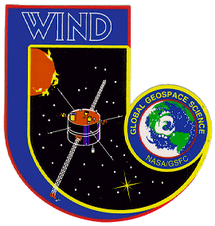

Figure 5 Project Logo

References

1. “Wind (Spacecraft).” Wikipedia, Wikimedia Foundation, 8 Feb. 2020, en.wikipedia.org/wiki/Wind_(spacecraft).
2. Tran, Lina. “25 Years of Science in the Solar Wind.” NASA, NASA, 31 Oct. 2019, [www.nasa.gov/feature/goddard/2019/25-years-of-science-in-the-solar-wind](http://www.nasa.gov/feature/goddard/2019/25-years-of-science-in-the-solar-wind).
3. Rockets and Missiles, [www.spaceline.org/rocketsum/delta-II-7000-series.html](http://www.spaceline.org/rocketsum/delta-II-7000-series.html).
4. “Polar (Satellite).” Wikipedia, Wikimedia Foundation, 28 Aug. 2019, en.wikipedia.org/wiki/Polar_(satellite).
5. “The Energetic Particles: Acceleration, Composition, and Transport (EPACT) Investiation on the Wind Spacecraft”. *Von Rosenvinge et al.*16, June, 1993. https://wind.nasa.gov/docs/EPACT_Rosenvinge_SSR1995.pdf
6. “The Global Geospace Science Satellite Wind.” NASA, NASA, heasarc.gsfc.nasa.gov/docs/heasarc/missions/wind.html.